Love in the Year of the Fire Horse: What 2026 Means for Your Relationships, Sign by Sign
- 8 hours ago
- 8 min read
This is the one year in 60 where your partner is most likely to cheat and most likely to propose. Here's why.

I've been reading fortunes for over 30 years. More than 20,000 card readings. I've sat across from people going through divorces, people falling in love for the first time at 50, people who stayed in the wrong relationship for a decade because they were afraid to look honestly at what the cards were telling them.
And every time a Fire Horse year comes around, which is only once every 60 years, I brace myself. Because what I see in the readings changes. The stakes get higher. The emotions run hotter. The outcomes swing harder in both directions.

I said the same thing about 2007. That was a Fire Pig year, my year. I was born in the Fire Pig year of 1947. When 2007 came around, I predicted extremes in every direction, and that's exactly what happened. The S&P 500 peaked in October. The iPhone launched in June. And the global financial system started cracking apart, all in the same twelve months. Higher highs and lower lows. The contradiction was the feature, not the bug.

Your love life works the same way in a year like this. Record proposals. Record divorces. Record passions, pointed in every direction. The Fire Horse doesn't do anything halfway.
We are in a Fire Horse year right now. 2026. And this one is faster, wilder, and harder to control than 2007.
Let me tell you what you're actually dealing with.

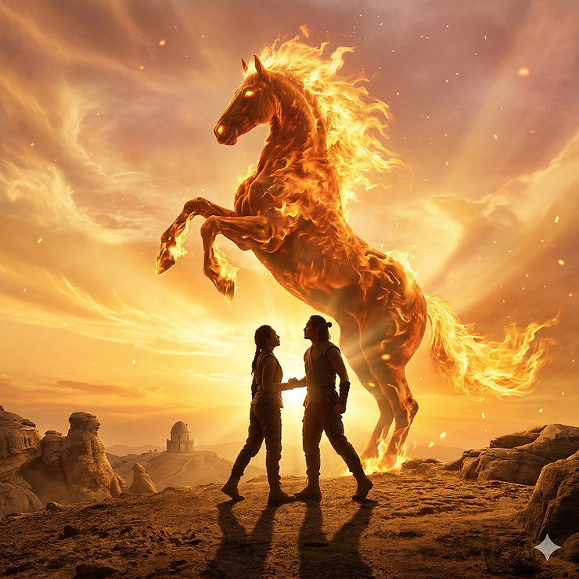

Why This Year Is Different
The Chinese zodiac runs on a 60-year cycle: 12 animals, each paired with one of five elements. Most years are a mix of energies. The Fire Horse is not most years.
The Horse is already the most yang, most intense animal in the zodiac. Fast-moving. Passionate. Freedom-loving. Action-oriented. It does nothing halfway.

Now take that Horse energy and put it inside a Fire year, which means the Horse's own elemental energy is also Fire, and you get a double fire situation. It's not a fireplace. It's a wildfire. And in matters of love, wildfire energy means passion, desire, and emotion are all amplified beyond what most people are used to managing.

The last Fire Horse year was 1966. In Japan, families were so afraid of Fire Horse daughters, believing they would be uncontrollable and bring disaster to their marriages, that Japan's birth rate dropped by roughly 25% in a single year. The total fertility rate fell from 2.14 in 1965 to 1.58 in 1966, one of the sharpest demographic declines in modern history, before bouncing all the way back to 2.23 the following year. It remains the most dramatic single-year fertility drop in Japan's postwar records.

Families made real decisions about whether to have children based on the energy of one year. That's not superstition. That's how seriously civilizations have taken Fire Horse energy when they understood what it meant.

Think about what that means for 2026's love landscape. The same volatility that suppressed birth rates in 1966 is the same energy that produces record proposals and record divorces in the same year. The contradiction IS the feature. I saw it in 2007 with markets. You're going to see it this year in relationships.

The Three Ways This Year Will Test Your Love Life

1. Uncontrolled Passion Becomes a Problem
The energy supporting passion in a double fire year is overwhelming. That sounds good, and it can be. But unmanaged passion doesn't stay pointed at your partner. It wanders.
In my readings this year, the peach card, which represents romantic temptation, attraction, and affairs, has been showing up in the problem position at an alarming rate. I've been doing this for three decades, and the frequency right now is notable.
This is the year when affairs happen. Not because people are bad. Because the fire energy is real, it's running hot, and if a relationship isn't already generating enough heat, people go looking for it somewhere else.

2. The Horse's Restlessness Becomes Abandonment
The Horse is the first animal in the zodiac to wander when it isn't satisfied. It needs to feel the energy. It needs to feel something. This year that restlessness is amplified in everyone, including your partner.
If your partner isn't getting passion, attention, and genuine connection from you right now, this is the year they leave. Not next year. This year. The Horse doesn't wait.

3. Hot Tempers Become Permanent Damage
Fire energy means arguments burn hotter than usual. Some of those arguments will clear the air. Fire can purify. But the leap from heated fight to breakup to "I want a divorce" is shorter this year than in any other year in the 60-year cycle.

In 2007, I watched markets peak and then collapse within the same twelve months. The same pattern plays out in relationships during fire years. The highs and lows don't happen in sequence. They happen simultaneously, in different households, sometimes in the same household at different moments.

Horse years run on a 12-year cycle. Look at what surrounded them: the early 1990s brought record divorce rates across the US and UK during and after the 1990 Horse year. The 2002 Horse year landed during one of the most emotionally volatile periods in recent memory, in the aftermath of September 11, when marriages both surged and crumbled. The pattern is consistent. Fire Horse years, which only come every 60 years, compress all of that volatility into a single extreme year.

The Big Picture: What This Year Actually Means
Here's what I've seen in years like this: it's an all-or-nothing year. The contradiction is the feature.
In 2007, the S&P 500 hit its all-time peak in October. The iPhone launched in June. And the global financial system began collapsing in between. All in the same year. Confidence was everywhere while the pipes were quietly clogging.

Your love life in 2026 follows the same pattern. Some people are going to find the relationship they've been looking for their whole lives, and when it hits, it hits fast and hard and real. Proposals happen. Marriages happen. Babies happen. Deep, lasting bonds form in Fire Horse years that carry people for decades.

Others will watch relationships that were already cracked finally break apart. Not because the year is unlucky. Because the heat reveals what was already true.
The Fire Horse is an accelerator. Volatile years reward people who pay attention and punish those who sleepwalk through them. I said that about 2007. It's even more true now, because the Fire Horse is faster and wilder than the Fire Pig ever was.

The question isn't whether this year will be extreme in love. It already is. The question is whether you're paying attention and positioning accordingly.

Your Love Forecast: By Sign
Scroll down to your sign. And then ask yourself whether you're really doing what it says.
Rat — High Risk. Your energy clashes directly with the Horse this year. Nothing good happens on autopilot. Pay attention, stay present, and actively tend your love life. Cleverness won't save you here. Presence will.
Ox — High Risk. The Ox's steadiness can become stubbornness in a year like this. Your partner may feel ignored rather than secure. Don't take them for granted. The Fire Horse doesn't forgive complacency.
Tiger — Exceptional Year. The Tiger is in the Horse's Trinity. The energy flows directly your way. This is one of the best years for love in the entire 60-year cycle. Proposals, marriages, deepening bonds. Go all out. Don't hold back.
Rabbit/Cat — Neutral, But Tiring. Your challenge is stamina. The pace of this year is faster than you like. Don't fade out. Stay in the game with your partner.
Dragon — Neutral. Your risk is distraction. You're always doing big things, but your partner needs fire from you this year. Stay present and the opportunity is real.
Snake — Mixed. You tend to go inward. This year demands the opposite. Be more outgoing than your comfort zone allows. The opportunity is there if you step toward it.
Horse — Challenging. Almost too much of a good thing. Your restless energy is amplified to an extreme. Fight the urge to run. Point your passion at your partner.
Sheep/Goat — Exceptional Year. The Goat is the Horse's soulmate sign in the Chinese zodiac. This could be the best year of your love life. Proposals, marriages, babies, genuine connection: it's all available to you. Lean all the way in.
Monkey — Mixed. Drop the mind games. This is not a year for cleverness in love. It's a year for raw, honest passion. Be real.
Rooster — Favorable. You get along well with the Horse, but perfectionism and control can hold you back. Let go of the checklist. Release your emotions. The year rewards you if you meet it.
Dog — Favorable. The Dog is in the Horse's Trinity alongside the Tiger. The energy supports you directly. Use this year to deepen bonds and act on feelings you've been holding back.
Pig — Challenging. Not unlucky, but demanding. Lean into your natural sensuality and express it clearly to your partner. You'll need to push yourself to keep up with the year's pace, but the reward is there if you do.

What To Do Right Now in The Year of Fire Horse
The Fire Horse doesn't reward passivity. It rewards the people who look honestly at where they are and then act.
So hold up the mirror.

Is your relationship generating real passion, or are you going through the motions? Is there temptation pulling at you, or at your partner, that you've been ignoring? Is there something you need to say, or do, or commit to, that you've been putting off?
This is the year where all of those questions get answered, whether you want them to or not. The fire forces the question. The only variable is whether you're the one asking it, or whether life is asking it for you.

I've been reading fortunes since before most of you were on the internet. I called 2007 before it happened. I'm telling you now: the Fire Horse year does to love what 2007 did to markets. It takes what's already there, amplifies it, and forces the question.
The people who came out well in 2007 weren't the ones who ignored the signals. They were the ones who saw both the risk and the opportunity and positioned accordingly.

In my three decades of readings, the peach card, which represents romantic temptation and affairs, shows up in the problem position noticeably more often in fire years than in water or wood years. In 2026, I'm seeing it at a rate that stands out even by fire year standards. When that card appears in the problem position, it doesn't mean an affair is inevitable. It means the conditions are ripe. Whether it happens depends on what you do next.

The Mahjong Mirror is a decision-making tool built for exactly that. It helps you see what's actually in your love life right now, the strengths, the threats, the timing, the blind spots, and then helps you figure out what to do about it.

The Mahjong Mirror launches July 27. If you want to understand your love life before the Fire Horse year decides it for you, this is where you start.

→ Learn more about The Mahjong Mirror
Bill Hajdu, The Firepig, has been practicing Chinese astrology and fortune-telling for over 30 years, with more than 20,000 card readings across clients in Vietnam, the US, and Asia. He is the author of The Mahjong Mirror, launching July 27, 2026.

